Hawk 4 Traffic Advisor
Operating Manual and Installation Instructions

Hawk 4 Traffic Advisor

Operating Manual and Installation Instructions

Warnings and Notices for Users and Installers
WARNING: Take CAUTION when installing
This document must be delivered to and read by the end user and installer as it serves to provide you with the required information for proper and safe use of your LED Equipped product. Before operating this or any LED Equipped products the user and installer must read this manual all the way through. You will find important information in this manual that could prevent property damage and/or serious injury to the user and installer. LED Equipped products are intended to alert pedestrians and other operators of the presence of personnel, the operation of emergency vehicles, an emergency site, and any warning needs. It is your responsibility to make sure you can proceed safely before driving against traffic, entering an intersection, responding to a high rate of speed, or walking on or around traffic lanes.
Your LED Equipped emergency vehicle devices should be tested daily to insure the device and all its functions are operating correctly. If you experience a malfunction contact LED Equipped's Customer Service immediately for troubleshooting options, or a warranty or service claim. You must ensure sure that the projection of the visual and audible is not blocked by vehicle components (i.e.: open trunks, visors, compartment doors), vehicles, other obstructions, or people. LED Equipped's sirens and other audible devices project sound in a forward direction and should be installed in a forward direction that faces away from the occupants of the vehicle.
This is professional grade equipment and is intended for strict use by authorized personal only. It is the user's responsibility to understand and obey all laws regarding emergency warning devices. You must know and be familiar with all applicable city, sate, and federal laws and regulations prior to the use of emergency vehicle warning devices. LED Equipped assumes no liability for any loss resulting from the use of this warning device. Proper installation is vital to the performance of the warning devices and safe operation of the emergency vehicle. Since the operator is under stressful environments the equipment must be properly wired and mounted to ensure effectiveness and safety. Therefore, controllers must be properly installed and placed within convenient reach of the operator so eye contact with the roadway is never lost. The effectiveness of your LED Equipped equipment is highly dependent upon correct mounting and wiring.
Improper wiring and mounting of the warning device will reduce the output and performance of the equipment. Emergency warning devices frequently require high electrical voltages and/or currents. Properly protect and use caution around live electrical connections. Grounding or shorting of electrical connections can cause high current arcing, which can cause severe personal injury and/or serious vehicle damage, including fire. Electromagnetic interference can be caused by many electronic devices used in emergency vehicles. To ensure that this doesn't happen to you, lights bars should be mounted a minimum of 12" - 34" from the radio antenna and do not power your equipment from the same circuit or share the same grounding circuit with radio communication equipment. After installation test all the vehicles equipment together to ensure everything operates free of interference. Driver and/or passenger airbags bags (SRS) will impact the way you mount your equipment. Any equipment installed in the deployment area of the airbags will damage or dislodge the airbags and sensors. This will also reduce the effectiveness of the airbags to protect the passengers and therefore these areas must be avoided. Installers must make sure that this equipment along with any parts, hardware, wiring, power supplies, and switch boxes do not interfere with the airbags, SRS wiring, or sensors. All LED Equipped equipment needs to be mounted and installed according to the vehicle manufactures instructions and securely attached to a part of the vehicle of sufficient strength to withstand the forces applied to the equipment. This device should be permanently mounted within the zones specified by the vehicle manufactures. This especially applies to equipment mounted on the exterior of the vehicle to avoid dislodging. When mounting units on the interior of the vehicle by a method other than permanent mount is discouraged as it may become too detached under aggressive driving conditions such as sudden breaking, collision, or swerving.

Important Points for Your Safety and Longevity of your Equipment
Installers are required to have a good understanding of automotive electronic, systems and procedures for proper installation.
- One should not stare directly into the LEDs as momentary blindness and/or eye damage may occur.
- One should not take any lights through a car wash. Use only water to clean the outer body/lens of your equipment.
- One should not use a pressure washer to clean any LED Equipped products. Inspect and test your product daily to insure it operates properly and is mounted correctly.
- One should not cut wires or work on a unit while the unit is still connected to a power source.
- One should not install this product or rout any wires through or in the deployment area of the airbag. Doing so may cause serious personal injury as it will damage or reduce the effectiveness of the airbag by causing the unit to become a projectile.
Reference the owner's manual for your vehicle to find the airbag deployment area. The User/Installer assumes all responsibility to determine proper mounting location, based on providing ultimate safety to all passengers in the vehicle.
- If the product requires you to drill holes the installer must ensure that the drilling process does not damage any vehicle components or other vital parts. Check all sides of the mounting surface before beginning to drill. Make sure to deburr all drilled holes and remove any metal remnants or shards to avoid injury and wires from becoming spliced. Grommets are to be installed in all wire passage holes.
- For LED Equipped products to operate at optimum efficiency a secure and good electrical connection to the Batteries Ground Post must be made. The recommended procedure requires the unit's ground wire be connected directly to the NEGATIVE (-) battery post.

Included Parts
The following parts are included with the Hawk 4 Traffic Advisor.
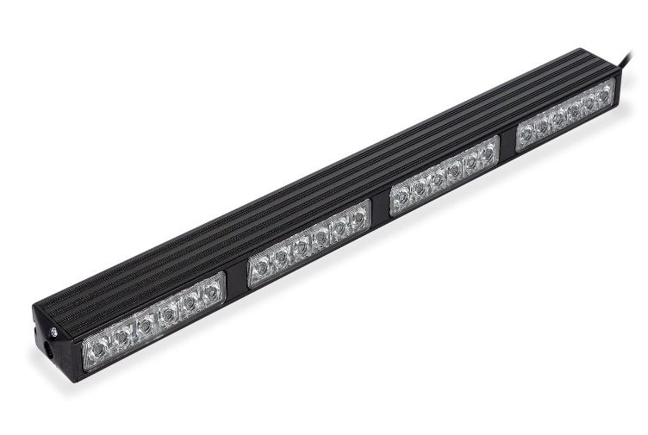
Hawk 4 Traffic Advisor

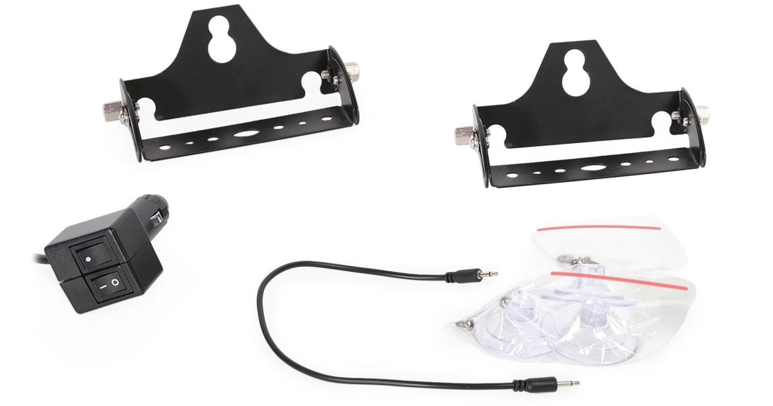
Hawk 4 Traffic Advisor Installation Accessories

Instructions for Wiring and Operation

Installation and Wiring
To ensure proper installation installers are required to have a good understanding of automotive electronic systems and procedures for proper installation.
When you are drilling into the vehicle's surfaces, ensure that the area is free of any electrical wires, vehicle upholstery, fuel lines, etc. that could be damaged. All wiring passing through drilled holes should use grommets and silicone sealant to prevent wire or moisture damage when passing through compartment walls.
WARNING! Larger wires and secure or tight connections will ensure longer service life for your product. It is highly recommended that soldered connections have heat shrink used to protect the connection. Special attention should be given to the location and method of splicing wires to make electrical connections to protect these splices from lost power or connection and corrosion.
Insulation displacement connectors are not to be used. To reduce voltage drop, minimize the number of splices in the wires. The current carrying capacity of wires and fuses will be significantly reduced under high ambient temperature (e.g. under the hood).
All wires should be in accordance with the minimum wire size and other recommendations made by the manufacturer and be protected from hot surfaces and moving parts. Grommets, cable ties, looms, and other installation hardware should be used to anchor and protect all wiring. Fuses should be properly sized and located as close to the power take off points as possible to protect the wiring and device. To protect against short circuits, a fuse is included by LED Equipped for all products. Do NOT use a fuse with a higher amp rating than the initial fuse included.
After removing your product from the packaging, ensure that you conduct a full bench test of your product prior to installation on your vehicle. To do this, connect your product 12v + (positive) and 12v – (negative) to an appropriate 12v + (positive) power source and 12v- (negative ground). Installers will typically want to use the 12v – (negative) battery terminal over a frame-ground installation for proper operation. Many LED Equipped vehicle light bars come preinstalled with a 12v auxiliary power connector (cigarette plug) for ease of installation and to allow for simplicity of bench testing of your product. Once connected to an appropriate 12v power source (and GND), test each functional element of your product to ensure proper operation. If it is identified that any function is not working properly as a result of your bench test, please contact LED Equipped for further diagnosis and resolution. DO NOT in any circumstance attempt to open the product light housing to investigate and resolve the issue on your own. Doing so will result in voiding of the factory warranty. Once a successful bench test has been completed, and you have ensured the proper operation of your product, please follow the instructions below to install your product in your vehicle.

Installing the Hawk 4 Traffic Advisor

Installing and using the Hawk 4 Traffic Advisor is as simple as inserting the prewired plug into a 12v auxiliary power outlet. Once connected to a 12v power source, the provided on/off rocker switch can be used to power on the Hawk 4 Traffic Advisor. A second momentary rocker switch is also provided on the prewired plug for pattern selection. To advance the pattern selection, press the pattern selection rocker switch once to advance through the included flash patterns.

The Hawk 4 Traffic Advisor also comes prewired to connect directly to an optional external switch box, which allows for use of the steady burn/cruise mode and optional takedown light functionality that is engineered into your Hawk 4 Traffic Advisor. In addition, the Hawk 4 Traffic Advisor is designed to allow for synchronization of multiple additional light heads to suit your unique needs for installation. LED Equipped offers a number of external switch box options for hardwiring the Hawk 4 Traffic Advisor for effortless integration and installation. Wiring specifications and wiring installation instructions for connecting your Hawk 4 Traffic Advisor can be found below.

Mounting the Hawk 4 Traffic Advisor to Your Vehicle

The Hawk 4 Traffic Advisor comes with the necessary hardware and brackets for mounting directly to your vehicle, either through the use of the included suction cups for mounting to your vehicle windows, or by securing the Hawk 4 Traffic Advisor directly to your vehicle. The included mounting bracket is fully adjustable to ensure that your Hawk 4 Traffic Advisor is mounted to maximize visibility on your vehicle. When securing the Hawk 4 Traffic Advisor directly to your vehicle, appropriate hardware should selected by the installer and installed in a manner so as to ensure that the Hawk 4 Traffic Advisor is mounted securely to your vehicle. Special attention should be given to the location and method of mounting your Hawk 4 Traffic Advisor directly to your vehicle so that it does not obstruct normal vehicle operation, and any direct mounting of the Hawk 4 Traffic Advisor does not compromise the safety support structure of your vehicle. Tampering with or altering vehicle safety and support features can result in injury or death.

Hawk 4 Traffic Advisor Wire Routing

To begin routing the wiring for your Hawk 4 Traffic Advisor, identify the desired wiring path to be used to facilitate the easiest and most direct path between the mounting location of your Hawk 4 Traffic Advisor and the desired location of your external switch box or controller, or the location of the 12v auxiliary power source that will be used to power your Hawk 4 Traffic Advisor. Identify a path where the wiring can be securely fastened to your vehicle throughout the vehicle compartment. Once a desired wiring path has been identified, route the wiring from your Hawk 4 Traffic Advisor securely through your vehicle compartment and to your external switch box or controller, or the location of the 12v auxiliary power source that will be used to power your Hawk 4 Traffic Advisor, securing the wiring using appropriate wiring fasteners and secure fastening locations on your vehicle.

Wiring the Hawk 4 Traffic Advisor

In addition to the preinstalled 12v plug, which can be utilized to power on and off your Hawk 4 Traffic Advisor as well as select the desired flash pattern without the need for any additional wiring, you can optionally utilize an external switch box or controller to directly wire you Hawk 4 Traffic Advisor and make use of the steady burn/cruise mode functionality, or the optional takedown mode if your Hawk 4 Traffic Advisor is so equipped.

Direct Wiring to an External Switch Box or Controller

The wiring specifications in Figure 1 below can be utilized for wiring your Hawk 4 Traffic Advisor directly to an external switch box or controller.

Figure 1

Hawk 4 Wiring Specifications
Wire Color | Function
Red | 12v + (Positive)
Black | 12v – (Negative)
Yellow | Flash Pattern Selection
White | Synchronization
Green | Cruise Mode (Steady Burn) or optional Takedown Mode (if equipped)

Utilizing an external switch box or controller, your Hawk 4 Traffic Advisor must be connected to an appropriate 12v + (positive) and 12v – (negative) power source for operation. Figure 2 below provides an illustrative representation of wiring the Hawk Traffic Advisor to an external switch box.

Wiring for flash pattern selection is accomplished through the use of a 12v + (positive) momentary switch on your external switch box or controller. Applying a momentary 12v + (positive) signal to the pattern selection wire will advance your Hawk 4 Traffic Advisor to the next available flash pattern. Applying the pattern selection wire to a 12v + (positive) power source continuously for approximately four (4) seconds will return the Hawk 4 Traffic Advisor to the first pattern (steady burn).
Wiring for Synchronization of Multiple Hawk Traffic Advisor Units
The Hawk Traffic Advisor has been engineered to allow the Hawk Traffic Advisors to be wired in a manner that allows for synchronization of the flash pattern across multiple units. Wiring the Hawk Traffic Advisors for synchronization requires simply bundling and connecting the white synchronization wires on each Hawk Traffic Advisor unit that are to be configured for synchronization. Once the white synchronization wires from each Hawk Traffic Advisor unit have been bundled and connected together, you may move on to programming the flash patterns as instructed below. Figure 2 below provides an illustrative representation of wiring the Hawk Traffic Advisor to an external switch box, including the wiring for the synchronization of multiple Hawk Traffic Advisors if so desired.

Wiring for Cruise or Takedown (if so equipped) Mode
Each Hawk 4 Traffic Advisor is also preconfigured to allow for a steady burn (cruise) pattern selection, or for the use of the optional Takedown mode if selected on your specific configuration. This setup will allow all connected light heads to operate at a steady burn, or in Takedown mode when so configured. It is necessary that a separate switch or button be used on your lighting control box to power the cruse or Takedown mode for individualized use of this functionality. To wire the cruise or Takedown mode, connect the cruise/Takedown mode (green) wire (or the bundled cruise/Takedown mode (green) wires for multiple Hawk Traffic Advisor units) to a 12v + (positive) power source. When connected to a 12v + (positive) power source, cruise or Takedown mode of the Hawk 4 Traffic Advisor will become activated. Figure 2 below provides an illustrative representation of wiring the Hawk Traffic Advisor to an external switch box, including the wiring for the use of cruise/Takedown mode if so desired.

Figure 2
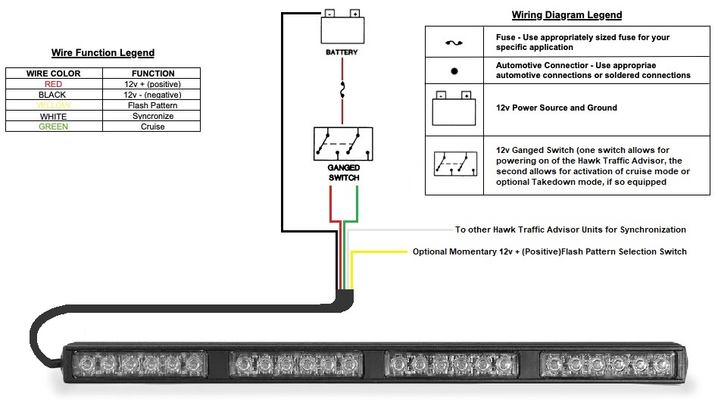

Selecting the Hawk 4 Traffic Advisor Flash Patterns

Once your installation of the Hawk 4 Traffic Advisor has been installed and wired in accordance with the wiring instructions identified above, selection of the preferred flash pattern can be performed using the included flash pattern rocker switch to cycle through available flash patterns. Alternately, touching the yellow flash pattern selection wire to an appropriate 12v + (positive) power source will advance to the next available flash pattern. This will allow you to cycle through the flash patterns noted below to select the desired pattern. Note that all LED Equipped lights are equipped with non-volatile memory which will recall the last selected flash pattern when turned on.

For synchronization of flash patterns across multiple Hawk Traffic Advisor units, apply the yellow flash pattern selection wire from each unit to an appropriate 12v + (positive) power source for approximately four (4) seconds to reset the light heads to a steady burn. With the synchronization wire for all Hawk Traffic Advisor units connected together, bundle all of the yellow flash pattern selection wires from each synchronized unit, and apply the bundled yellow flash pattern selection wires to an appropriate 12v + (positive) power source momentarily to advance to the next available flash pattern. Applying the bundled yellow flash pattern selection wires from each unit to an appropriate 12v + (positive) power source for approximately four (4) seconds will reset the light heads to a steady burn to begin the process of selecting your desired flash pattern from the beginning of the available flash patterns, if necessary.

Figure 1

Hawk 4 Traffic Advisor Flash Patterns
Pattern  Number | Function | Pattern  Number | Function
1 | Quad Burst – Split | 12 | Super Flash – Alternating *
2 | Quad Burst – All | 13 | Quad/Single with Quad Burst – Split
3 | Quad Burst – Alternating * | 14 | Quad/Single with Quad Burst
4 | Quad – Split | 15 | Accelerator - Split
5 | Quad – All | 16 | Accelerator – All
6 | Quad – Alternating * | 17 | Express Flash
7 | Single – Split | 18 | California Steady with Pulse
8 | Single – All | 19 | California Steady
9 | Single – Alternating * | 20 | Steady All
10 | Super Flash – Split | 21 | Cycle Flash – Split and All
11 | Super Flash – All | 22 | Off

Hawk 4 Traffic Advisor Optional Accessories

Handheld Controller
Product Number: A-1391

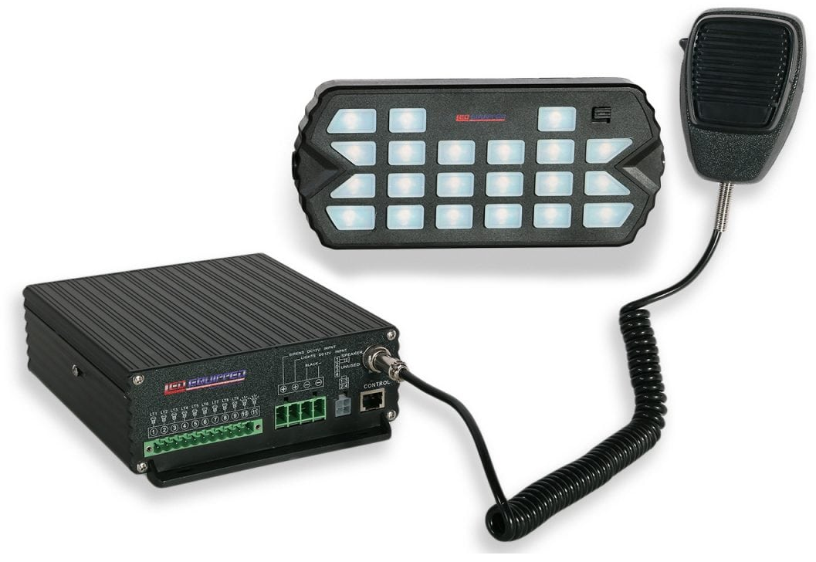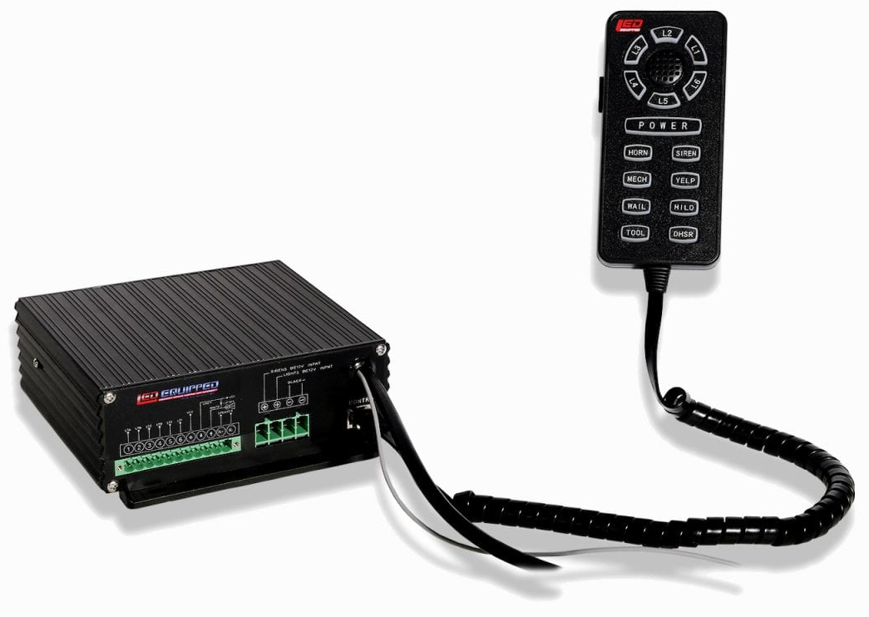
Black Falcon Siren and Control Unit  Product Number: A-1237 (100w) and  A-1368 (200w) | Pelican Siren and Control Unit  Product Number: A-1108 (100w) and  A-1109 (200w)

At LEDEQUIPPED, we know that you need affordable lighting for your police, EMS, fire, construction, or towing vehicles and that safety and reliability are important to you. That’s why all of our LED products feature powerful, up to date Generation LED lighting, perfect for your police, fire, construction, or EMS vehicle. LED Equipped focuses on a mission to carry out business ethically and with integrity, provide powerful products of the highest quality, maintain excellent and affordable prices, and to establish an unparalleled costumer service relationship beginning with establishing trust with our customers. As a provider of emergency vehicle lighting, we value the honesty, professionalism, and expertise present within our customer base.
For any questions regarding our products, contact us by calling us at +1 800-846-3940 or email us at sales@ledequipped.com.

