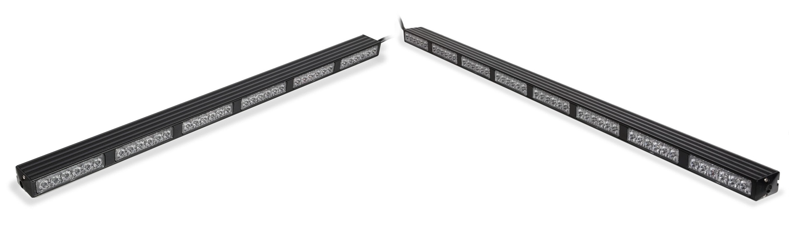Hawk Warning Stick and Arrow Stick Control Box Operating Manual and Installation Instructions

Hawk Warning Stick and Arrow Stick Control Box Operating Manual and Installation Instructions

Warnings and Notices for Users and Installers

WARNING: Take CAUTION when installing
This document must be delivered to and read by the end user and installer as it serves to provide you with the required information for proper and safe use of your LEDEQUIPPED product. Before operating this or any LEDEQUIPPED products the user and installer must read this manual all the way through. You will find important information in this manual that could prevent property damage and/or serious injury to the user and installer. LEDEQUIPPED products are intended to alert pedestrians and other operators of the presence of personnel, the operation of emergency vehicles, an emergency site, and any warning needs. It is your responsibility to make sure you can proceed safely before driving against traffic, entering an intersection, responding to a high rate of speed, or walking on or around traffic lanes.
Your LEDEQUIPPED emergency vehicle devices should be tested daily to insure the device and all it's functions are operating correctly. If you experience a malfunction contact LEDEQUIPPED's Customer Service immediately for troubleshooting options, or a warranty or service claim. You must ensure sure that the projection of the visual and audible is not blocked by vehicle components (i.e.: open trunks, visors, compartment doors), vehicles, other obstructions, or people. LEDEQUIPPED's sirens and other audible devices project sound in a forward direction and should be installed in a forward direction that faces away from the occupants of the vehicle.

This is professional grade equipment and is intended for strict use by authorized personal only. It is the user's responsibility to understand and obey all laws regarding emergency warning devices. You must know and be familiar with all applicable city, sate, and federal laws and regulations prior to the use of emergency vehicle warning devices. LEDEQUIPPED assumes no liability for any loss resulting from the use of this warning device. Proper installation is vital to the performance of the warning devices and safe operation of the emergency vehicle. Since the operator is under stressful environments the equipment must be properly wired and mounted to ensure effectiveness and safety. Therefore, controllers must be properly installed and placed within convenient reach of the operator so eye contact with the roadway is never lost. The effectiveness of your LEDEQUIPPED equipment is highly dependent upon correct mounting and wiring.

Improper wiring and mounting of the warning device will reduce the output and performance of the equipment. Emergency warning devices frequently require high electrical voltages and/or currents. Properly protect and use caution around live electrical connections. Grounding or shorting of electrical connections can cause high current arcing, which can cause severe personal injury and/or serious vehicle damage, including fire. Electromagnetic interference can be caused by many electronic devices used in emergency vehicles. To ensure that this doesn't happen to you, lights bars should be mounted a minimum of 12" - 34" from the radio antenna and do not power your equipment from the same circuit or share the

same grounding circuit with radio communication equipment. After installation test all the vehicles equipment together to ensure everything operates free of interference. Driver and/or passenger airbags bags (SRS) will impact the way you mount your equipment. Any equipment installed in the deployment area of the airbags will damage or dislodge the airbags and sensors. This will also reduce the effectiveness of the airbags to protect the passengers and therefore these areas must be avoided. Installers must make sure that this equipment along with any parts, hardware, wiring, power supplies, and switch boxes do not interfere with the airbags, SRS wiring, or sensors. All LEDEQUIPPED equipment needs to be mounted and installed according to the vehicle manufactures instructions and securely attached to a part of the vehicle of sufficient strength to withstand the forces applied to the equipment. This device should be permanently mounted within the zones specified by the vehicle manufactures. This especially applies to equipment mounted on the exterior of the vehicle to avoid dislodging. When mounting units on the interior of the vehicle by a method other than permanent mount is discouraged as the it may become to detached under aggressive driving conditions such as sudden breaking, collision, or swerving.

Important Points for Your Safety and Longevity of your Equipment
Installers are required to have a good understanding of automotive electronic, systems and procedures for proper installation.
- One should not stare directly into the LEDs as momentary blindness and/or eye damage may occur.
- One should not take any lights through a car wash. Use only water to clean the outer body/lens of your equipment. –
- One should not use a pressure washer to clean any LEDEQUIPPED products. Inspect and test your product daily to insure it operates properly and is mounted correctly.
- One should not cut wires or work on a unit while the unit is still connected to a powersource.
- One should not install this product or rout any wires through or in the deployment area of the airbag. Doing so may cause serious personal injury as it will damage or reduce the effectiveness of the airbag by causing the unit to become a projectile.
Reference the owner's manual for your vehicle to find the airbag deployment area. The User/Installer assumes all responsibility to determine proper mounting location, based on providing ultimate safety to all passengers in the vehicle.
- If the product requires you to drill holes the installer must ensure that the drilling process does not damage any vehicle components or other vital parts. Check all sides of the mounting surface before beginning to drill. Make sure to deburr all drilled holes and remove any metal remnants or shards to avoid injury and wires from becoming spliced. Grommets are to be installed in all wire passage holes.
- For LEDEQUIPPED products to operate at optimum efficiency a secure and good electrical connection to the Batteries Ground Post must be made. The recommended procedure requires the unit's ground wire be connected directly to the NEGATIVE (-) battery post.

Instructions for Wiring and Operation

Installation and Wiring

To ensure proper installation installers are required to have a good understanding of automotive electronic, systems and procedures for proper installation.
When you are drilling into the vehicle's surfaces, ensure that the area is free of any electrical wires, vehicle upholstery, fuel lines, etc. that could be damaged. All wiring passing through drilled holes should use grommets and silicone sealant to prevent wire or moisture damage when passing through compartment walls.
WARNING! Larger wires and secure or tight connections will ensure longer service life for your product. It is highly recommended that soldered connections have heat shrink used to protect the connection. Special attention should be given to the location and method of splicing wires to make electrical connections to protect these splices from lost power or connection and corrosion.
Insulation displacement connectors are not to be used. To reduce voltage drop, minimize the number of splices in the wires. The current carrying capacity of wires and fuses will be significantly reduced under high ambient temperature (e.g. under the hood).
All wires should be in accordance with the minimum wire size and other recommendations made by the manufacturer and be protected from hot surfaces and moving parts. Grommets, cable ties, looms, and other installation hardware should be used to anchor and protect all wiring. Fuses should be properly sized and located as close to the power take off points as possible to protect the wiring and device. To protect against short circuits, a fuse is included by LEDEQUIPPED for all products. Do NOT use a fuse with a higher amp rating than the initial fuse included.

Fig. 1

Your Hawk Warning Stick and Arrow Stick Control Box comes prewired to connect directly to our Hawk 6 and Hawk 8 Traffic Advisors (Fig. 1).

Fig 2.

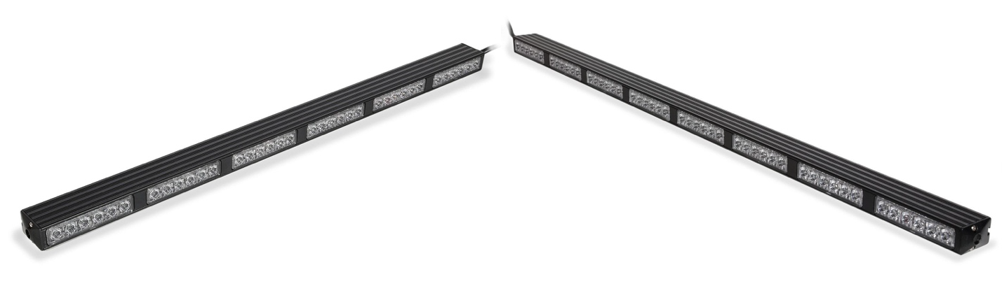
Please note that the Hawk 6 or Hawk 8 Traffic Advisor must be purchased separately in order to complete this installation (Fig. 2). The Hawk 4, Hawk 2, and Hawk 1 Traffic Advisors are not compatible with the Hawk Warning Stick and Arrow Stick Control Box

Wiring the Hawk Warning Stick Arrow Control Box to the Hawk 6 or Hawk 8 Traffic Advisor

Wiring the Hawk Warning Stick Arrow Control Box to the Hawk 6 or Hawk 8 Traffic Advisor is as simple as connecting the prewired Hawk Warning Stick Arrow Control Box to the prewired Hawk 6 or Hawk 8 Traffic Advisor according to the table included in Figure 3 below. Please note that the 12v + (Positive/Red Wires) and 12v – (Negative/Black Wires) wiring connections must be made to an appropriate 12v power source and ground, in order for your Hawk Warning Stick Arrow Control Box and Hawk 6 or Hawk 8 Traffic Advisor to function properly. The image included in Figure 4 below provides a visual representation for how to wire the Hawk Warning Stick Arrow Control Box to the Hawk 6 or Hawk 8 Traffic Advisor.

All wiring connections should be secured using appropriate automotive connectors or through the use of soldered connections. All connections should be protected by using heat shrink wire wrap in order to protect the connection. Special attention should be given to the location and method of splicing wires to make electrical connections to protect these splices from lost power or connection and corrosion.

Fig. 3

Hawk Warning Stick and Arrow Stick Control Box
Wire Color
Function
Red
Black Yellow Brown Orange Blue Green
White
12v + (Positive)
12v – (Negative) Flash Pattern Selection Power On/Off
Right to Left Arrow Left to Right Arrow Center Out Arrow
Steady Burn
Hawk 6 or Hawk 8 Traffic Advisor
Wire Color
Function
Red
Black Yellow Brown Purple Orange Grey
Green
12v + (Positive)
12v – (Negative) Flash Pattern Selection Power On/Off
Right to Left Arrow Left to Right Arrow Center Out Arrow
Steady Burn

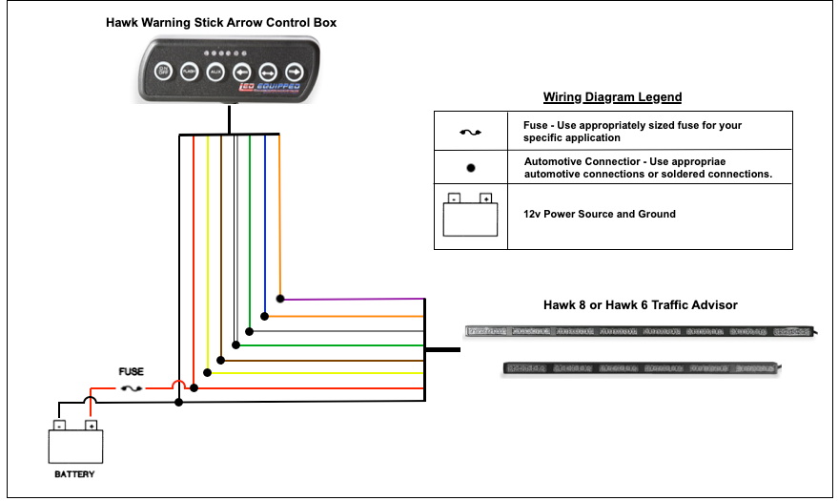Operation

Fig. 4

The Hawk Warning Stick Arrow Control Box includes six soft touch buttons to operate your Hawk 6 or Hawk 8 Traffic Advisor Box.

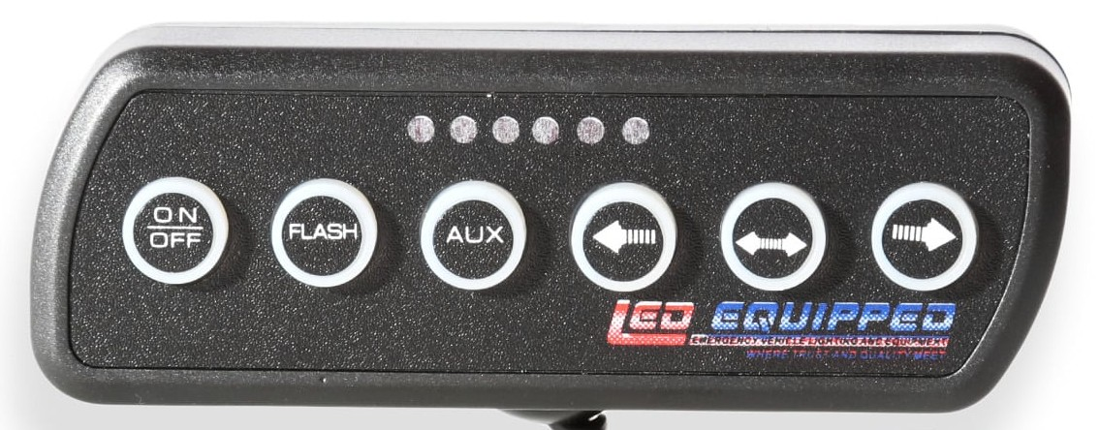
The respective button functions are:

On/Off Power on and power off of you Hawk 6 or Hawk 8 Traffic Advisor.
Flash Set your non-arrow flash pattern for your Hawk 6 or Hawk 8 Traffic Advisor. All LEDEQUIPPED lights are equipped with non-volatile memory which will recall the last set flash pattern when your Hawk 6 or Hawk 8 Traffic Advisor is turned on.

C/C Solid burn of your Hawk 6 or Hawk 8 Traffic Advisor (all light heads are powered on)
¬ Right to left arrow pattern on your Hawk 6 or Hawk 8 Traffic Advisor.
↔ Center out arrow pattern on your Hawk 6 or Hawk 8 Traffic Advisor.
→ Left to right arrow pattern on your Hawk 6 or Hawk 8 Traffic Advisor.

Depressing the arrow pattern or steady burn buttons once will enable the selected function. To return to the non-arrow flash pattern, depress the arrow pattern or steady burn button again.

The Hawk Warning Stick Arrow Control Box is also equipped with an LED display which displays the current flash or arrow pattern selected.

At LEDEQUIPPED, we know that you need affordable lighting for your police, EMS, fire, construction, or towing vehicles and that safety and reliability are important to you. That’s why all of our LED products feature powerful up do date Generation LED lighting, perfect for your police, fire, construction, or EMS vehicle. LEDEQUIPPED focuses on a mission to carry out business ethically and with integrity, provide powerful products of the highest quality, maintain excellent and affordable prices, and to establish an unparalleled customer service relationship beginning with establishing trust with our costumers. As a provider of emergency vehicle lighting, we value the honesty, professionalism, and expertise present within our customer base

For any questions regarding our products, contact us by calling us at +1 800-846-3940 or email us at sales@ledequipped.com.

