Predator Emergency LED

18 Inch Light Bar

Operating Manual and Installation Instructions

Predator Emergency LED 18 Inch Light Bar

Operating Manual and Installation Instructions

Warnings and Notices for Users and Installers
WARNING: Take CAUTION when installing
This document must be delivered to and read by the end user and installer as it serves to provide you with the required information for proper and safe use of your LEDEQUIPPED product. Before operating this or any LEDEQUIPPED products the user and installer must read this manual all the way through. You will find important information in this manual that could prevent property damage and/or serious injury to the user and installer. LEDEQUIPPED products are intended to alert pedestrians and other operators of the presence of personnel, the operation of emergency vehicles, an emergency site, and any warning needs. It is your responsibility to make sure you can proceed safely before driving against traffic, entering an intersection, responding to a high rate of speed, or walking on or around traffic lanes.
Your LEDEQUIPPED emergency vehicle devices should be tested daily to insure the device and all its functions are operating correctly. If you experience a malfunction contact LEDEQUIPPED's Customer Service immediately for troubleshooting options, or a warranty or service claim. You must ensure sure that the projection of the visual and audible is not blocked by vehicle components (i.e.: open trunks, visors, compartment doors), vehicles, other obstructions, or people. LEDEQUIPPED's sirens and other audible devices project sound in a forward direction and should be installed in a forward direction that faces away from the occupants of the vehicle.
This is professional grade equipment and is intended for strict use by authorized personal only. It is the user's responsibility to understand and obey all laws regarding emergency warning devices. You must know and be familiar with all applicable city, sate, and federal laws and regulations prior to the use of emergency vehicle warning devices. LEDEQUIPPED assumes no liability for any loss resulting from the use of this warning device. Proper installation is vital to the performance of the warning devices and safe operation of the emergency vehicle. Since the operator is under stressful environments the equipment must be properly wired and mounted to ensure effectiveness and safety. Therefore, controllers must be properly installed and placed within convenient reach of the operator so eye contact with the roadway is never lost. The effectiveness of your LEDEQUIPPED equipment is highly dependent upon correct mounting and wiring.
Improper wiring and mounting of the warning device will reduce the output and performance of the equipment. Emergency warning devices frequently require high electrical voltages and/or currents. Properly protect and use caution around live electrical connections. Grounding or shorting of electrical connections can cause high current arcing, which can cause severe personal injury and/or serious vehicle damage, including fire. Electromagnetic interference can be caused by many electronic devices used in emergency vehicles. To ensure that this doesn't happen to you, lights bars should be mounted a minimum of 12" - 34" from the radio antenna and do not power your equipment from the same circuit or share the same grounding circuit with radio communication equipment. After installation test all the vehicles equipment together to ensure everything operates free of interference. Driver and/or passenger airbags bags (SRS) will impact the way you mount your equipment. Any equipment installed in the deployment area of the airbags will damage or dislodge the airbags and sensors. This will also reduce the effectiveness of the airbags to protect the passengers and therefore these areas must be avoided. Installers must make sure that this equipment along with any parts, hardware, wiring, power supplies, and switch boxes do not interfere with the airbags, SRS wiring, or sensors. All LEDEQUIPPED equipment needs to be mounted and installed according to the vehicle manufactures instructions and securely attached to a part of the vehicle of sufficient strength to withstand the forces applied to the equipment. This device should be permanently mounted within the zones specified by the vehicle manufactures. This especially applies to equipment mounted on the exterior of the vehicle to avoid dislodging. When mounting units on the interior of the vehicle by a method other than permanent mount is discouraged as it may become too detached under aggressive driving conditions such as sudden breaking, collision, or swerving.

Important Points for Your Safety and Longevity of your Equipment
Installers are required to have a good understanding of automotive electronic, systems and procedures for proper installation.
- One should not stare directly into the LEDs as momentary blindness and/or eye damage may occur.
- One should not take any lights through a car wash. Use only water to clean the outer body/lens of your equipment. –
- One should not use a pressure washer to clean any LEDEQUIPPED products. Inspect and test your product daily to insure it operates properly and is mounted correctly.
- One should not cut wires or work on a unit while the unit is still connected to a power source.
- One should not install this product or rout any wires through or in the deployment area of the airbag. Doing so may cause serious personal injury as it will damage or reduce the effectiveness of the airbag by causing the unit to become a projectile.
Reference the owner's manual for your vehicle to find the airbag deployment area. The User/Installer assumes all responsibility to determine proper mounting location, based on providing ultimate safety to all passengers in the vehicle.
- If the product requires you to drill holes the installer must ensure that the drilling process does not damage any vehicle components or other vital parts. Check all sides of the mounting surface before beginning to drill. Make sure to deburr all drilled holes and remove any metal remnants or shards to avoid injury and wires from becoming spliced. Grommets are to be installed in all wire passage holes.
- For LEDEQUIPPED products to operate at optimum efficiency a secure and good electrical connection to the Batteries Ground Post must be made. The recommended procedure requires the unit's ground wire be connected directly to the NEGATIVE (-) battery post.

Included Parts
The following parts are included with the Predator Emergency LED 18 Inch Light Bar.

Predator Emergency LED 18 Inch Light Bar
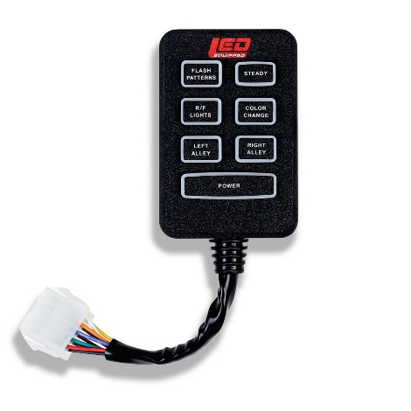
Predator Emergency LED Light Bar Controller

Instructions for Wiring and Operation

Installation and Wiring
To ensure proper installation installers are required to have a good understanding of automotive electronic, systems and procedures for proper installation.
When you are drilling into the vehicle's surfaces, ensure that the area is free of any electrical wires, vehicle upholstery, fuel lines, etc. that could be damaged. All wiring passing through drilled holes should use grommets and silicone sealant to prevent wire or moisture damage when passing through compartment walls.
WARNING! Larger wires and secure or tight connections will ensure longer service life for your product. It is highly recommended that soldered connections have heat shrink used to protect the connection. Special attention should be given to the location and method of splicing wires to make electrical connections to protect these splices from lost power or connection and corrosion.
Insulation displacement connectors are not to be used. To reduce voltage drop, minimize the number of splices in the wires. The current carrying capacity of wires and fuses will be significantly reduced under high ambient temperature (e.g. under the hood).
All wires should be in accordance with the minimum wire size and other recommendations made by the manufacturer and be protected from hot surfaces and moving parts. Grommets, cable ties, looms, and other installation hardware should be used to anchor and protect all wiring. Fuses should be properly sized and located as close to the power take off points as possible to protect the wiring and device. To protect against short circuits, a fuse is included by LEDEQUIPPED for all products. Do NOT use a fuse with a higher amp rating than the initial fuse included.
After removing your product from the packaging, ensure that you conduct a full bench test of your product prior to installation on your vehicle. To do this, connect your product 12v + (positive) and 12v – (negative) to an appropriate 12v + (positive) power source and 12v- (negative ground). Installers will typically want to use the 12v – (negative) battery terminal over a frame-ground installation for proper operation. Many LEDEQUIPPED vehicle light bars come preinstalled with a 12v auxiliary power connector (cigarette plug) for ease of installation and to allow for simplicity of bench testing of your product. Once connected to an appropriate 12v power source (and GND), test each functional element of your product to ensure proper operation. If it is identified that any function is not working properly as a result of your bench test, please contact LEDEQUIPPED for further diagnosis and resolution. DO NOT in any circumstance attempt to open the product light housing to investigate and resolve the issue on your own. Doing so will result in voiding of the factory warranty. Once a successful bench test has been completed, and you have ensured the proper operation of your product, please follow the instructions below to install your product in your vehicle.

Installing the Predator Emergency LED 18 Inch Light Bar

The Predator Emergency LED Light Bar is designed to be surface mounted using the included magnetic feet, on the top of your vehicle, or optionally, to permanently affix your Predator Emergency LED Light Bar to the top of your vehicle through secure mounting holes included on the magnetic mounting feet. To ensure proper placement of your Predator Emergency LED Light Bar, it is recommended that you measure and mark your installation location to prior to permanent installation. As noted above, the Predator Emergency LED Light Bar comes pre-equipped with magnetic mounting feet that secure to the top of your vehicle during installation. Please note: Magnetic mounting of your Predator Emergency LED Light Bar is not recommended for use on vehicles in motion in speeds in excess of fifty (50) miles per hour, especially in windy and rough terrain areas. For vehicles that will be operating at speeds in excess of fifty (50) miles per hour, permanent mounting of your Predator Emergency LED Light Bar is recommended.

Magnetic Mounting

Once a desired mounting location has been selected, ensure that the mounting location is free and clear of debris or dirt to ensure maximum adhesion to your vehicle exterior. It is recommended that you completely clean and dry the mounting location of your Predator Emergency LED Light Bar prior to installation. Position your Predator Emergency LED Light Bar and check to ensure that the location is satisfactory before moving onto wiring your Predator Emergency LED Light Bar. Because the Predator Emergency LED Light Bar is intended to be mounted using the included magnetic feet, repositioning your light bar is easily done to ensure desired placement on your vehicle. Please take note that sliding the magnetic feet on your vehicle exterior may cause damage to the vehicle finish, and therefore it is essential that when repositioning your Predator Emergency LED Light Bar, that you remove the light bar completely from the vehicle prior to repositioning. Damage caused by sliding the magnetic feet on your vehicle is at the sole and exclusive responsibility of the vehicle installer or vehicle owner and LEDEQUIPPED cannot be held responsible for damage caused to the exterior of your vehicle during installation.

Permanent Mounting

Please note: Permanent mounting of your Predator Emergency LED Light Bar will require the installer to permanently affix the light bar to the exterior of your vehicle using stainless steel mounting hardware that will be selected for use at the discretion of the installer. There are many options for hardware to be utilized in permanently affixing the Predator Emergency LED Light Bar and LEDEQUIPPED does not sanction any one preferred method or the hardware that is selected to be used for installation. The selection of the installation hardware and permanent mounting methodology used for the Predator Emergency LED Light Bar is at the sole and exclusive discretion and responsibility of the vehicle installer or vehicle owner and LEDEQUIPPED cannot be held responsible for damage caused to your vehicle as a result of permanent mounting of your Predator Emergency LED Light Bar.

Although any mounting approach may be chosen and used by the vehicle installer or vehicle owner, the following instructions can be used for informational use and reference purposes only if permanent mounting of your Predator Emergency LED Light Bar is desired.

Once a desired mounting location for your Predator Emergency LED Light Bar has been selected, ensure that the mounting location is free and clear of debris or dirt. It is recommended that you completely clean and dry the mounting location of your Predator Emergency LED Light Bar prior to installation. Position your Predator Emergency LED Light Bar and check to ensure that the location is satisfactory before moving on to permanently affixing your Predator Emergency LED Light Bar to your vehicle. Permanent mounting of your Predator Emergency LED Light Bar to your vehicle will require drilling into the exterior of your vehicle and therefore proper positioning MUST be done prior to installation. Repositioning your light bar is easily done to ensure desired placement on your vehicle. Please take note that sliding the magnetic feet on your vehicle exterior may cause damage to the vehicle finish, and therefore it is essential that when repositioning your Predator Emergency LED Light Bar, that you remove the light bar completely from the vehicle prior to repositioning. Damage caused by sliding the magnetic feet on your vehicle is at the sole and exclusive responsibility of the vehicle installer or vehicle owner and LEDEQUIPPED cannot be held responsible for damage caused to the exterior of your vehicle during installation.

To begin permanent installation of your Predator Emergency LED Light Bar once a final mounting location has been determined, remove the rubber feet and magnets from the bottom of the light bar by loosening and removing the bolt that is holding the rubber feet and magnets to the light bar. Doing this will expose the preconfigured mounting holes (four in total) to be used in a permanent installation. With the mounting holes exposed, mark the location of each mounting hole on the exterior of your vehicle. These markings will be used as a guide to predrill holes in your vehicle exterior for installation.

Once the mounting locations have been identified on your vehicle, select the hardware to be utilized in the installation. It is recommended that stainless steel hardware (not supplied) be utilized when affixing the Predator Emergency LED Light Bar permanently to the exterior of your vehicle, so as to reduce the possibility of degradation of the mounting hardware when exposed to outside elements. Optional hardware that may be utilized, include self-tapping screws, appropriately sized bolts with washers and self-locking nuts, or simple metal screws. The selection of hardware to be utilized is at the sole and exclusive discretion of the vehicle installer or vehicle owner, and the optional hardware identified above should be considered for reference purposes only. Once the desired mounting hardware has been selected, determine the appropriate sized metal drilling bit for pre-drilling the mounting holes for your hardware. Predrilling, using an appropriately sized metal drilling bit, will help to reduce the potential for damage to your vehicle exterior during installation. Please note: Many vehicles have included safety supports incorporated as part of the vehicle roof design. It is critical that drilling into the safety support structure of your vehicle roof be avoided at all costs. Tampering with or altering vehicle safety and support features can result in injury or death. Additionally, the vehicle installer or vehicle owner should take appropriate precautions to avoid damaging the headliner of your vehicle interior while predrilling the mounting holes for your Predator Emergency LED Light Bar. In many instances, temporary removal of the interior headliner of your vehicle is strongly desired to avoid such damage from occurring, as well as to facilitate the routing of wiring for the Predator Emergency LED Light Bar within your vehicle. Please follow your vehicle’s manufacturer instructions for the removal and reinstallation of any vehicle components such as the interior headliner or moldings within your vehicle.

Once the vehicle mounting holes have been made, it would be an appropriate time to determine the desired Predator Emergency LED Light Bar wiring method to be used. As described below, there are two options for routing the wiring of your Predator Emergency LED Light Bar. The first method is to run the wiring along the roof to a location where you can easily access the passenger compartment of your vehicle without having to make any holes in your vehicle exterior. The second method is to drill a hole in your vehicle exterior, near to where the wiring harness exits the light housing, through which to route the vehicle wiring harness into the passenger compartment of your vehicle. If it is determined that the wiring for your Predator Emergency LED Light Bar is to be routed through an opening in your vehicle’s exterior, it is recommended that the determination of location and creation of that opening be performed prior to final installation and permanently affixing your Predator Emergency LED Light Bar to your vehicle. Please refer to the wiring instructions below for further details on the routing and wiring of your Predator Emergency LED Light Bar.

To permanently affix your Predator Emergency LED Light Bar, using the vehicle installer or vehicle owner selected hardware, ensure that proper silicone sealant be applied to each mounting hole before and after installation of the mounting hardware. It is critical to utilize an appropriate silicone sealant for any holes in the exterior of your vehicle to fully seal and prevent moisture or harmful gasses from entering your vehicle’s passenger compartment. It is recommended that proper silicon sealant be applied into each mounting hole prior to installation of the mounting hardware, and again to seal the installed mounting hardware for maximum affect.

Once your Predator Emergency LED Light Bar has been mounted to the exterior of your vehicle, either through use of the provided magnetic mounting feet, or through permanent installation, you may move onto wiring your Predator Emergency LED Light Bar following the instructions below.

Wiring the Predator Emergency LED 18 Inch Light Bar

The Predator Emergency LED 18 Inch Light Bar is fully encapsulated, weather and vibration resistant, and comes preconfigured for use with the supplied Predator Emergency LED Light Bar controller using the preinstalled 12v auxiliary power connecter (cigarette plug) as the primary power source. The supplied Predator Emergency LED Light Bar controller uses a prewired quick snap connector to connect directly to the included wiring housing on the Predator Emergency LED Light Bar.

There are two primary installation options for routing the wiring of your Predator Emergency LED Light Bar. The least invasive method for wiring your Predator Emergency LED Light Bar is to install the wiring so that it does not require any modifications to the exterior of your vehicle, therefore eliminating any need to create holes through which to run the wiring in to the vehicle passenger compartment. The second method, similar to the permanent mounting option detailed above, involves routing the Predator Emergency LED Light Bar wiring harness through a hole created in the exterior of your vehicle and entering into the vehicle compartment at a location nearer to the final installation location of your Predator Emergency LED Light Bar. While both methods are described below, routing the Predator Emergency LED Light Bar wiring harness through an opening created in the exterior of your vehicle will need to be done at the vehicle installer and vehicle owner’s sole and exclusive liability. LEDEQUIPPED takes no responsibility for any damage to your vehicle during the course of an installation.

Each Predator Emergency LED Light Bar unit is designed for ease of installation and wiring and comes pre-equipped with a 12v auxiliary power connector (cigarette plug) and a prewired easy-connect wire harness for seamless connection to the provided Predator Emergency LED Light Bar controller. Optionally, the Predator Emergency LED Light Bar can be hardwired directly to an external switch box or controller for ease of use and adaptability. The Predator Emergency LED Light Bar comes with fifteen (15) preconfigured flash patterns, as well as four (4) distinct traffic advisory patterns, which can be activated with the touch of a button. The engineering and adaptability of the Predator Emergency LED Light Bar allows for installers to create seamless integration of this unit for your specific application.

Hardwiring your Predator Emergency LED Light Bar to an external switch box can be accomplished using the wiring specifications included in Figure 2 below. Please note that the 12v + (Positive/Red Wires) and 12v – (Negative/Black Wires) wiring connections must be made to an appropriate 12v power source and ground in order for your Predator Emergency LED 18 Inch Light Bars to function properly. Appropriately sized automotive wiring should be used for wiring to an external switch box or controller.

All wiring connections should be secured using appropriate automotive connectors or through the use of soldered connections. All connections should be protected by using heat shrink wire wrap in order to protect the connection. Special attention should be given to the location and method of splicing wires to make electrical connections to protect these splices from lost power or connection and corrosion.

Figure 2

Predator Emergency LED 18 Inch Light Bars
Wire Color | Function | Wire Color | Function
Red | 12v + (Positive) | Grey | On/Off
Black | 12v – (Negative) | Yellow | Flash Pattern Selection
Blue | Right Alley | White | Left Alley
Brown | Front Lights Only | Orange | Rear Lights Only
Green | Steady Burn (Cruise Mode) | Purple | Color Change

External Wire Routing
To begin externally routing the wiring for your Predator Emergency LED Light Bar, identify the desired wiring path to be used to facilitate the easiest and most direct path between the mounting location of your Predator Emergency LED Light Bar and the desired location of your Predator Emergency LED Light Bar controller or external switch box or controller. Identify a path where the wiring harness can be securely fastened to the exterior of your vehicle prior to where it enters the vehicle compartment. Some options include running the wiring along existing roof rails, down the side of the rear window of your vehicle, or down the side of the windshield of your vehicle, where the wiring is out of the way and does not impede or obstruct the safe operation of your vehicle in all operating environments. It is critical that no matter which routing path is chosen, that there are secure fastening points to which you can secure the wiring harness of your Predator Emergency LED Light Bar. Loose or insecure routing of the wiring harness of your Predator Emergency LED Light Bar can lead to damage to your vehicle and/or damage to the Predator Emergency LED Light Bar. Identify an access point through which you can route the wiring harness into the passenger compartment of your vehicle. Some locations that are typically used are through the firewall or through preexisting pass-through locations in your vehicle exterior. Once a desired wiring path and access point have been identified, route the wiring harness from your Predator Emergency LED Light Bar into your vehicle compartment, securing using appropriate wiring fasteners and secure fastening locations on your vehicle.

Wiring the Predator Emergency LED Light Bar Controller and Preinstalled 12v Auxiliary Power Connector (Cigarette Plug)
Once the wiring harness has been securely fastened to the exterior of your vehicle and into the passenger compartment, continue to route the wiring harness to the desired controller location. If using the included Predator Emergency LED Light Bar controller, simply connect the 12v auxiliary power connector (cigarette plug) into an available 12v auxiliary power supply in your vehicle, and connect the preinstalled quick snap wiring connector between the Predator Emergency LED Light Bar wire harness and Predator Emergency LED Light Bar controller. If using an external switch box or controller, proceed to the wiring instructions below for further detail.

Please refer to Figure 3 below for a visual representation of how to wire the Predator Emergency LED Light Bar using the preinstalled 12v auxiliary power connector (cigarette plug) and quick snap wiring connector.

Figure 3

Wiring the Predator Emergency LED Light Bar to an External Switch Box or Controller
Once the wiring harness has been securely fastened to the exterior of your vehicle and into the passenger compartment, continue to route the wiring harness to the existing external switch box or controller location. In order to utilize an external switch box or controller, the installer is required to remove the existing 12v auxiliary power connector and the quick snap wiring connector to expose the individual wires that are used to power and control the Predator Emergency LED Light Bar.

Once the existing 12v auxiliary power connector and the quick snap wiring connector have been removed exposing the individual wires used to power and control the Predator Emergency LED Light Bar, wiring to an external switch box or controller can be done following the wiring functions defined in Figure 2. Utilizing an external switch box or controller requires the availability of up to eight (8) functional buttons, seven (7) of which will be need to be able to apply a constant 12v + (positive) power source to utilize all of the available functions engineered into the Predator Emergency LED Light Bar, as well as one button that will be able to apply a momentary 12v + (positive) power source to cycle through the available flash patterns of the Predator Emergency LED Light Bar.

For wiring the Predator Emergency LED Light Bar to an external switch box or controller, the 12v + (positive) and 12v – (negative) wires must be connected to a continuous 12v power source. Using the wiring functions described in Figure 2 above, wire each of the remaining functional buttons to a 12v + (positive) power source to- allow for a customized use of an external switch box or controller to operate your Predator Emergency LED Light Bar. All wiring connections should be secured using appropriate automotive connectors or through the use of soldered connections. All connections should be protected by using heat shrink wire wrap in order to protect the connection. Special attention should be given to the location and method of splicing wires to make electrical connections to protect these splices from lost power or connection and corrosion.

Please refer to Figure 4 below for a visual representation of how to wire the Predator Emergency LED Light Bar for use with an external switch box or controller.

Figure 4

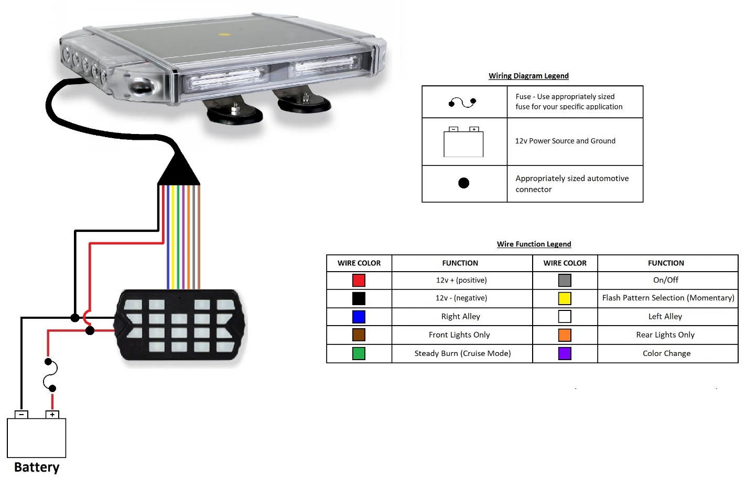

All LEDEQUIPPED lights are equipped with non-volatile memory which will recall the last selected flash pattern when turned on. Please refer to Figure 5 below for a complete listing of the available flash patterns included with the Predator Emergency LED Light Bar.

Wiring the Predator Emergency LED Light Bar Extension Cable (Optional Part A-1323)
For installations requiring an extension of the existing wiring bundle that is included with your Predator Emergency LED Light Bar, an optional ten (10) foot Mini Light Bar Extension Cable (Part A-1323) is available to assist in the ease of installation. Installation and addition of the extension cable is made simple using the preinstalled quick snap wiring connector that is currently used to connect the Predator Emergency LED Light Bar wire harness and Predator Emergency LED Light Bar controller. Install the Mini Light Bar Extension Cable by simply plugging in the quick snap wiring connector to the Predator Emergency LED Light Bar wire harness and connect the other end to the quick snap wiring connector on the Predator Emergency LED Light Bar controller for an additional ten (10) feet of available wiring, for a total of twenty (20) feet of continuous wiring to customize your installation.

Figure 5

Predator 18 Inch Emergency LED Light Bar Flash Patterns
Pattern  Number | Function | Pattern  Number | Function
1 | Quad Burst – Split | 9 | Right to Left
2 | Super Flash – Split | 10 | Left to Right
3 | Warp -All | 11 | Stacking Right to Left/Left to Right
4 | Quad Burst – Alternating | 12 | Double Flash Clockwise Rotation
5 | Spread - All | 13 | Double Flash Counter Clockwise Rotation
6 | Single with Quad Burst – All | 14 | Single Flash Clockwise Rotation
7 | Steady Burn Right Half. Quad Flash Left Half | 15 | Single Flash Counter Clockwise Rotation
8 | Steady Burn Left Half. Quad Flash Right Half

Selecting the Predator Emergency LED Light Bar Flash Pattern

Once your Predator Emergency LED 18 Inch Light Bar has been installed and wired in accordance with the wiring instructions identified above, selection of the preferred flash pattern can be performed by utilizing the momentary Flash Patterns button, or the momentary button utilized on the external switch box or controller if that installation method was selected. This will allow you to cycle through the flash patterns noted above to select the desired pattern. Note that all LEDEQUIPPED lights are equipped with non-volatile memory which will recall the last selected flash pattern when turned on.

Operating the Predator Emergency LED Light Bar

Once installed, operation of the Predator Emergency LED Light Bar using the provided controller is simple and easy. The chart in Figure 6 below details the functions of each button on your Predator Emergency LED Light Bar Controller and Figure 7 below will give a detailed description of the functionality that is preconfigured using each button on the Predator Emergency LED Light Bar Controller.

Figure 6
7
6
5
4
3
1
2

Predator Emergency LED 18 Inch Light bar Controller Functions
Button | Function | Button | Function
1 | Flash Pattern Selection | 2 | Enable Steady Burn  (Cruse Mode)
3 | Blue – Enable Rear Lights Only  Red – Enable Front Lights Only | 4 | Color Change (Only Used with Dual Color Light Bars)
5 | Enable the Left Alley Light (Steady White Burn) | 6 | Enable the Right Alley Light (Steady White Burn)
7 |  | Power – On / Off

Figure 7

Button Functional Descriptions
Button | Functional Description
Flash Patterns (1) | Select the desired flash pattern of the Predator Emergency LED Light Bar. This momentary button, when depressed, advances to the next available flash pattern.
Steady (2) | Enable the steady burn (cruse mode) on the light bar. This button applies a 12v + (positive) power source to make the Predator Emergency LED Light Bar burn steady (all lights on), in what is also called “Cruise Mode”. This function, when enabled, will activate all light heads within the Predator Emergency LED Light Bar to operate at a steady burn. Pressing the button a second time will return to the previously enabled flash pattern.
R/F Lights (3) | The Predator Emergency LED Light Bar has the ability to enable use of either the front of the light bar only (four front LED modules enabled), or to enable the use of the rear of the light bar only (four rear LED modules enabled plus both alley lights). Pressing the R/F Lights button the first time will apply a 12v + (positive) power source to make the Predator Emergency LED Light Bar enable the rear lights only, and the button on the controller will glow steady blue to signify that the rear lights only are enabled. Pressing the R/F Lights button a second time will apply a 12v + (positive) power source to make the Predator Emergency LED Light Bar enable the front lights only, and the button on the controller will glow steady red to signify that the front lights only are enabled. Pressing the R/F Lights button a third time will return to the previously enabled flash pattern on the Predator Emergency LED Light Bar.  When either the front or rear lights only are enabled, pressing the Flash Patterns button will change the flash pattern currently in use on the front or rear lights respectively. When pressing the momentary Flash Patterns button, the front or rear lights, currently enabled on the R/F Lights button, will advance to the next available flash pattern. When enabling the front or rear lights the next time, the non-volatile memory will revert to the previously selected flash pattern.
Color Change (4) | This button is only utilized on Predator Emergency LED Light Bars that are configured with the Dual Color option. This option allows a user to select a primary color (or split set of colors) as well as an additional secondary color option (white only or amber only) on the light bar. Pressing the Color Change button will apply a 12v + (positive) power source to make the Predator Emergency LED Light Bar switch between the primary color option and the secondary color option on the light bar.
Left Alley (5) | Pressing the Left Alley button will apply a 12v + (positive) power source to make the Predator Emergency LED Light Bar enable the Left Alley light to emit a steady white light for greater illumination on the left side of the light bar. Regardless of the color of the Left Alley light when operating normally, when the Left Alley light button is depressed, the color will change to a steady white light.
Right Alley (6) | Pressing the Right Alley button will apply a 12v + (positive) power source to make the Predator Emergency LED Light Bar enable the Right Alley light to emit a steady white light for greater illumination on the right side of the light bar. Regardless of the color of the Right Alley light when operating normally, when the Right Alley light button is depressed, the color will change to a steady white light.
Power (7) | Pressing the Power button once will turn the Predator Emergency LED Light Bar on. Pressing the Power button a second time will turn the Predator Emergency LED Light Bar off.

Predator Emergency LED 18 Inch Light bar Optional Accessories

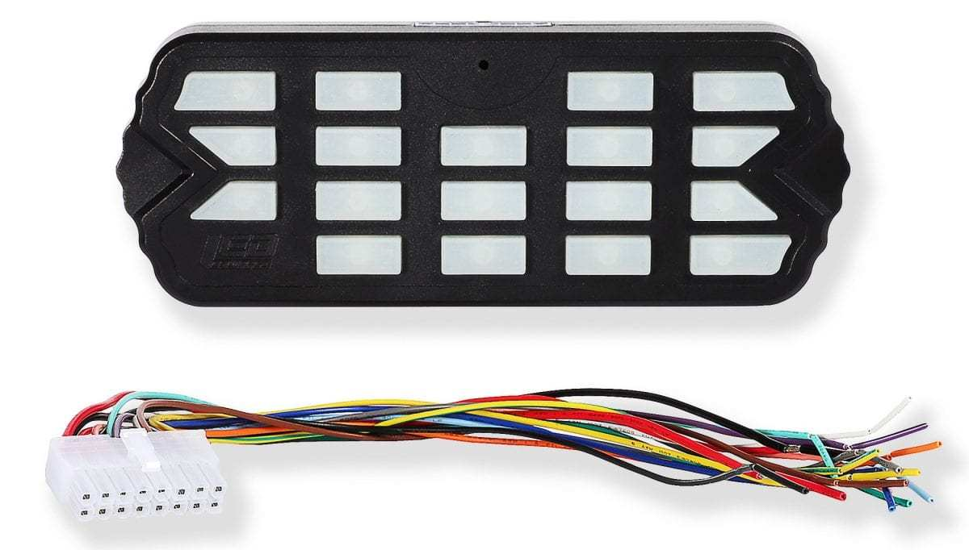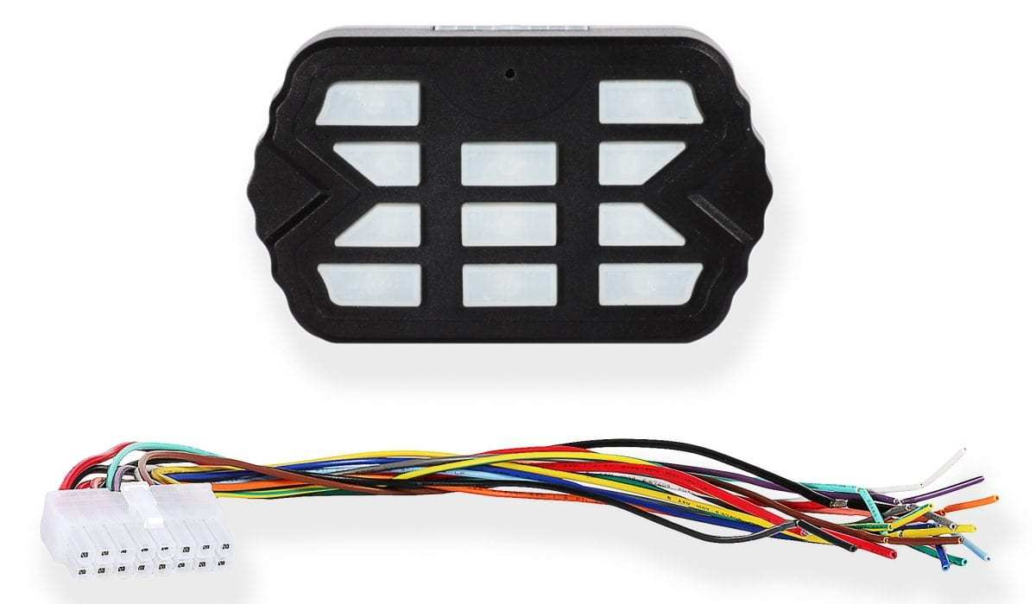
Combat Controller  Product Number: A-1516 | Combat Mini Controller  Product Number: A-1515
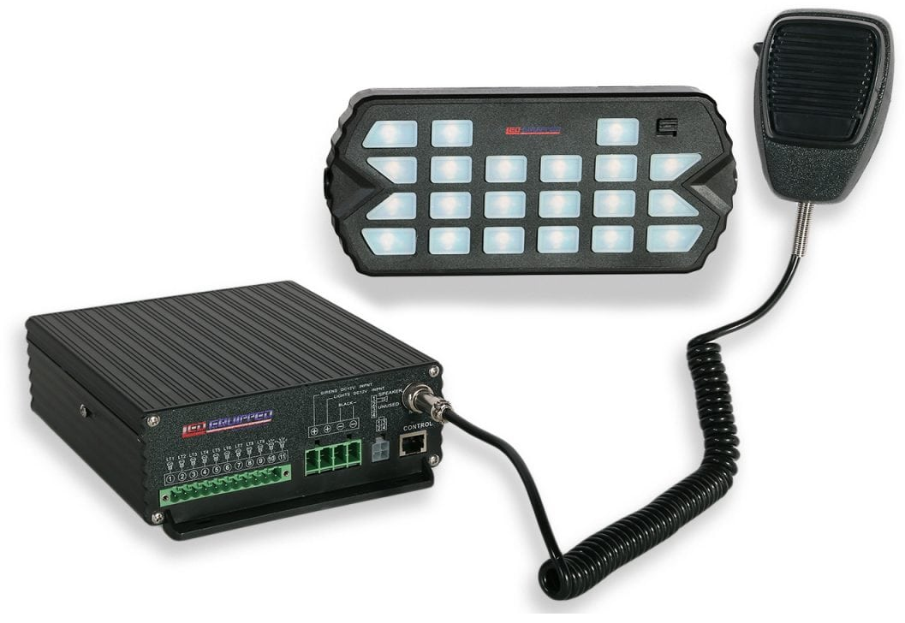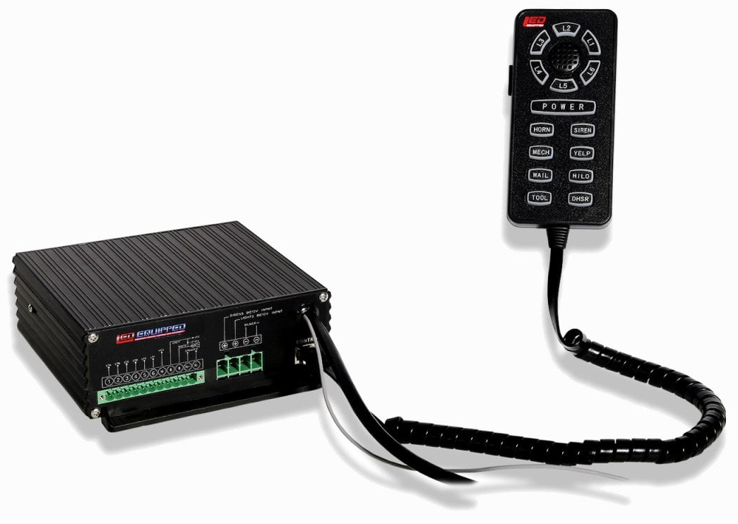
Black Falcon Siren and Control Unit  Product Number: A-1237 (100w) and  A-1368 (200w) | Pelican Siren and Control Unit  Product Number: A-1108 (100w) and  A-1109 (200w)
Predator Mini Bar Extension Cable
A-1323

At LEDEQUIPPED, we know that you need affordable lighting for your police, EMS, fire, construction, or towing vehicles and that safety and reliability are important to you. That’s why all of our LED products feature powerful up do date Generation LED lighting, perfect for your police, fire, construction, or EMS vehicle. LEDEQUIPPED focuses on a mission to carry out business ethically and with integrity, provide powerful products of the highest quality, maintain excellent and affordable prices, and to establish an unparalleled customer service relationship beginning with establishing trust with our customers. As a provider of emergency vehicle lighting, we value the honesty, professionalism, and expertise present within our customer base
For any questions regarding our products, contact us by calling us at +1 800-846-3940 or email us at sales@ledequipped.com.

