Hunter Series Interior Visor Light Bar
Operating Manual and Installation Instructions

Hunter Series Interior Visor Light Bar

Operating Manual and Installation Instructions

Warnings and Notices for Users and Installers
WARNING: Take CAUTION when installing
This document must be delivered to and read by the end user and installer as it serves to provide you with the required information for proper and safe use of your LEDEQUIPPED product. Before operating this or any LEDEQUIPPED products the user and installer must read this manual all the way through. You will find important information in this manual that could prevent property damage and/or serious injury to the user and installer. LEDEQUIPPED products are intended to alert pedestrians and other operators of the presence of personnel, the operation of emergency vehicles, an emergency site, and any warning needs. It is your responsibility to make sure you can proceed safely before driving against traffic, entering an intersection, responding to a high rate of speed, or walking on or around traffic lanes.
Your LEDEQUIPPED emergency vehicle devices should be tested daily to insure the device and all it's functions are operating correctly. If you experience a malfunction contact LEDEQUIPPED's Customer Service immediately for troubleshooting options, or a warranty or service claim. You must ensure sure that the projection of the visual and audible is not blocked by vehicle components (i.e.: open trunks, visors, compartment doors), vehicles, other obstructions, or people. LEDEQUIPPED's sirens and other audible devices project sound in a forward direction and should be installed in a forward direction that faces away from the occupants of the vehicle.

This is professional grade equipment and is intended for strict use by authorized personal only. It is the user's responsibility to understand and obey all laws regarding emergency warning devices. You must know and be familiar with all applicable city, sate, and federal laws and regulations prior to the use of emergency vehicle warning devices. LEDEQUIPPED assumes no liability for any loss resulting from the use of this warning device. Proper installation is vital to the performance of the warning devices and safe operation of the emergency vehicle. Since the operator is under stressful environments the equipment must be properly wired and mounted to ensure effectiveness and safety. Therefore, controllers must be properly installed and placed within convenient reach of the operator so eye contact with the roadway is never lost. The effectiveness of your LEDEQUIPPED equipment is highly dependent upon correct mounting and wiring.

Improper wiring and mounting of the warning device will reduce the output and performance of the equipment. Emergency warning devices frequently require high electrical voltages and/or currents. Properly protect and use caution around live electrical connections. Grounding or shorting of electrical connections can cause high current arcing, which can cause severe personal injury and/or serious vehicle damage, including fire. Electromagnetic interference can be caused by many electronic devices used in emergency vehicles. To ensure that this doesn't happen to you, lights bars should be mounted a minimum of 12" - 34" from the radio antenna and do not power your equipment from the same circuit or share the same grounding circuit with radio communication equipment. After installation test all the vehicles equipment together to ensure everything operates free of interference. Driver and/or passenger airbags bags (SRS) will impact the way you mount your equipment. Any equipment installed in the deployment area of the airbags will damage or dislodge the airbags and sensors. This will also reduce the effectiveness of the airbags to protect the passengers and therefore these areas must be avoided. Installers must make sure that this equipment along with any parts, hardware, wiring, power supplies, and switch boxes do not interfere with the airbags, SRS wiring, or sensors. All LEDEQUIPPED equipment needs to be mounted and installed according to the vehicle manufactures instructions and securely attached to a part of the vehicle of sufficient strength to withstand the forces applied to the equipment. This device should be permanently mounted within the zones specified by the vehicle manufactures. This especially applies to equipment mounted on the exterior of the vehicle to avoid dislodging. When mounting units on the interior of the vehicle by a method other than permanent mount is discouraged as the it may become to detached under aggressive driving conditions such as sudden breaking, collision, or swerving.

Important Points for Your Safety and Longevity of your Equipment
Installers are required to have a good understanding of automotive electronic, systems and procedures for proper installation.
- One should not stare directly into the LEDs as momentary blindness and/or eye damage may occur.
- One should not take any lights through a car wash. Use only water to clean the outer body/lens of your equipment. –
- One should not use a pressure washer to clean any LEDEQUIPPED products. Inspect and test your product daily to insure it operates properly and is mounted correctly.
- One should not cut wires or work on a unit while the unit is still connected to a power source.
- One should not install this product or rout any wires through or in the deployment area of the airbag. Doing so may cause serious personal injury as it will damage or reduce the effectiveness of the airbag by causing the unit to become a projectile.
Reference the owner's manual for your vehicle to find the airbag deployment area. The User/Installer assumes all responsibility to determine proper mounting location, based on providing ultimate safety to all passengers in the vehicle.
- If the product requires you to drill holes the installer must ensure that the drilling process does not damage any vehicle components or other vital parts. Check all sides of the mounting surface before beginning to drill. Make sure to deburr all drilled holes and remove any metal remnants or shards to avoid injury and wires from becoming spliced. Grommets are to be installed in all wire passage holes.
- For LEDEQUIPPED products to operate at optimum efficiency a secure and good electrical connection to the Batteries Ground Post must be made. The recommended procedure requires the unit's ground wire be connected directly to the NEGATIVE (-) battery post.
Included Parts and Accessories
The following parts are included with the Hunter Series Interior Visor LED Light Bar.
Hunter Series Visor Light Bar
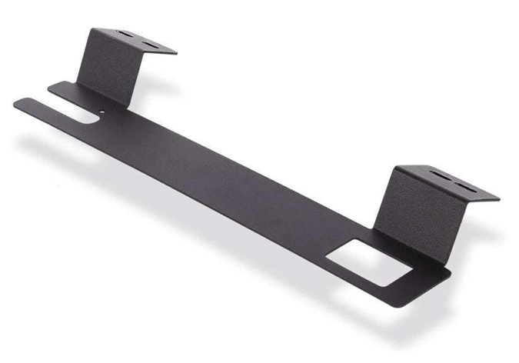
Visor Mounting Brackets (x2) |  | Light Bar Mounting Brackets (x4)

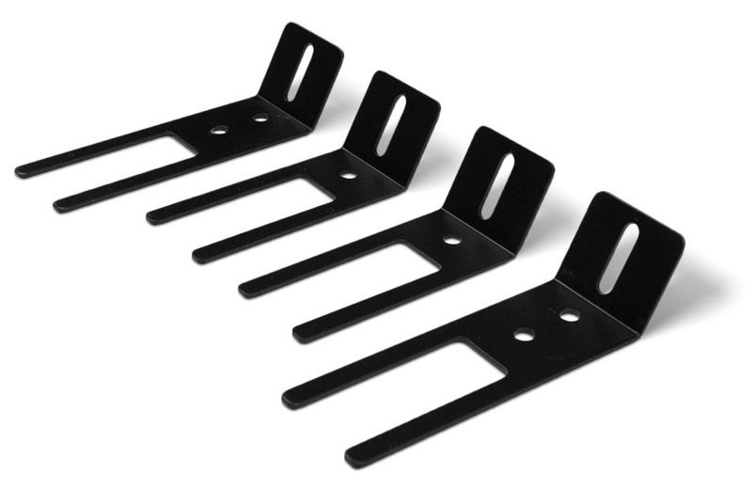
Light Bar Mounting Brackets (x4) |  | Alternative Fork Visor Mounting Brackets

Flashback Shield (x2) |  | Mounting Hardware (various)

Instructions for Wiring and Operation

Installation and Optional Wiring
To ensure proper installation installers are required to have a good understanding of automotive electronic, systems and procedures for proper installation.
When you are drilling into the vehicle's surfaces, ensure that the area is free of any electrical wires, vehicle upholstery, fuel lines, etc. that could be damaged. All wiring passing through drilled holes should use grommets and silicone sealant to prevent wire or moisture damage when passing through compartment walls.
WARNING! Larger wires and secure or tight connections will ensure longer service life for your product. It is highly recommended that soldered connections have heat shrink used to protect the connection. Special attention should be given to the location and method of splicing wires to make electrical connections to protect these splices from lost power or connection and corrosion.
Insulation displacement connectors are not to be used. To reduce voltage drop, minimize the number of splices in the wires. The current carrying capacity of wires and fuses will be significantly reduced under high ambient temperature (e.g. under the hood).
All wires should be in accordance with the minimum wire size and other recommendations made by the manufacturer and be protected from hot surfaces and moving parts. Grommets, cable ties, looms, and other installation hardware should be used to anchor and protect all wiring. Fuses should be properly sized and located as close to the power take off points as possible to protect the wiring and device. To protect against short circuits, a fuse is included by LEDEQUIPPED for all products. Do NOT use a fuse with a higher amp rating than the initial fuse included.

Operating the Hunter Series Interior Visor Light Bar

Wiring the Hunter Series Interior Visor Light Bar is as simple as inserting the prewired plug into a 12v auxiliary power outlet. Once connected to a 12v power source, the provided on/off rocker switch can be used to power on the Hunter Series Interior Visor Light Bar.

The Hunter Series Interior Visor Light Bar includes a driver side, built-in controller which allows the user to select the functions that are desired during operation. Figure 1 below identifies the functions that come standard when using the Hunter Series Interior Visor Light Bar.

The Hunter Series Interior Visor Light Bar also comes prewired to connect directly to an optional external switch box. LEDEQUIPPED offers a number of external switch box options for hardwiring the Hunter Series Interior Visor Light Bar for effortless integration and installation.

The Hunter Series Interior Visor Light Bar can be hard wired to provide a constant power source for powering the unit. To hardwire the unit to a constant power source, connect the 12v + (Positive/Red Wires) and 12v – (Negative/Black Wires) to an appropriate 12v power source and ground. Please note that when hardwiring the unit to an appropriate 12v power source and ground, an appropriately sized inline fuse should be installed in order for your Hunter Series Interior Visor Light Bar to function properly. Please note that in order to hard wire your Hunter Series Interior Visor Light Bar, the existing 12v auxiliary power adapter will be required to be removed.

Fig. 1

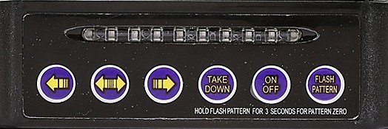

Hunter Series Interior Visor Light Bar
Button | Function
 | Flash Pattern Selection
 | Right to Left Arrow
 | Left to Right Arrow
 | Center Out Arrow
 | Take Down (If Equipped)
 | Power On/Off

All wiring connections should be secured using appropriate automotive connectors or through the use of soldered connections. All connections should be protected by using heat shrink wire wrap in order to protect the connection. Special attention should be given to the location and method of splicing wires to make electrical connections to protect these splices from lost power or connection and corrosion.

The Hunter Series Interior Visor Light Bar has been designed for ease of installation and adaptation for use with multiple units with limited additional wiring. This design allows for installers to create seamless integration of these units for your specific application.

Installing the Hunter Series Interior Visor Light Bar

The Hunter Series Interior Visor Light Bar is designed to be mounted within the vehicle using the existing sun visor mounting hardware included in your vehicle. The provided variety of installation brackets allows for the customization of installation to meet various vehicle configurations and can be adapted to meet the exact specifications of the existing vehicle sun visor mounting hardware.

- To install your Hunter Series Interior Visor Light Bar, first identify the existing sun visor mounting points, which will serve as your vehicle mounting points.
- Using the provided mounting brackets identify those that will provide the most secure mounting within your vehicle given the configuration of your existing sun visor mounting points.
- Loosening the existing sun visor mounting hardware will assist in placing the mounting brackets around the sun visor mounting points, and slide the mounting brackets between the headliner in your vehicle and the mounting existing sun visor points. In order to access the existing sun visor mounting points hardware, there may be removable clips that are required to be removed as part of this step in the installation process.
- When installing your Hunter Series Interior Visor Light Bar, it is important to keep the light head units as far towards the outside of your vehicle as possible, so as not to obstruct the operation and use of the rear view mirror. Mounting your Hunter Series Interior Visor Light Bar too close to the center of your windshield may cause your rear view mirror to become obstructed, which poses an immediate safety hazard and should NEVER be done.
- Once you have installed your Hunter Series Interior Visor Light Bar and positioned the light head units properly, tighten the existing sun visor mounting hardware to form a secure connection. Please note that in some installations, you may be required to bend the provided mounting hardware to achieve a secure fit in your vehicle. A secure fit to your vehicle is critical to making sure the Hunter Series Interior Visor Light Bar is firmly secured after installation.
- Once your Hunter Series Interior Visor Light Bar has been installed, you may connect the wiring harness between the two light head units, and run the wires to your 12v auxiliary power source or external controller. Be sure that you so not install or run any wiring that would obstruct the operation or deployment of air bags or obstruct the view out of the vehicle. Mounting that would obstruct the operation or deployment of an air bag or other vehicle safety system could cause damage or serious personal injury. It is the responsibility of the installer and the vehicle owner to ensure that that the installation of you Hunter Series Interior Visor Light Bar does not interfere with existing vehicle safety systems. Installation in contradiction to these instructions will be at the installer and the vehicle owner’s sole and exclusive liability.
- Once installed, your Hunter Series Interior Visor Light Bar may require the installation and use of the provided flashback shield to reduce or eliminate flashback during the operation of you Hunter Series Interior Visor Light Bar. The flashback shield comes with necessary mounting hardware to install the flashback shield directly onto your Hunter Series Interior Visor Light Bar. Use two (2) small screws provided with your Hunter Series Interior Visor Light Bar on each side of the flashback shield to attach the flashback shield to your light bar. Adjustments may be required to ensure a tight fit within your vehicle. Flashback resulting from the installation of your Hunter Series Interior Visor Light Bar may cause serious obstruction to visibility outside of your vehicle that could lead to serious harm or injury during operation. Please ensure that all necessary mounting precautions are taken to limit or avoid entirely all interior Hunter Series Interior Visor Light Bar flashback. Installation in contradiction to these instructions will be at the installer and the vehicle owner’s sole and exclusive liability.

At LEDEQUIPPED, we know that you need affordable lighting for your police, EMS, fire, construction, or towing vehicles and that safety and reliability are important to you. That’s why all of our LED products feature powerful up do date Generation LED lighting, perfect for your police, fire, construction, or EMS vehicle. LEDEQUIPPED focuses on a mission to carry out business ethically and with integrity, provide powerful products of the highest quality, maintain excellent and affordable prices, and to establish an unparalleled customer service relationship beginning with establishing trust with our costumers. As a provider of emergency vehicle lighting, we value the honesty, professionalism, and expertise present within our customer base
For any questions regarding our products, contact us by calling us at +1 800-846-3940 or email us at sales@ledequipped.com.

