Handheld Controller

Operating Manual and Installation Instructions

Handheld Controller

Operating Manual and Installation Instructions

Warnings and Notices for Users and Installers
WARNING: Take CAUTION when installing
This document must be delivered to and read by the end user and installer as it serves to provide you with the required information for proper and safe use of your LED Equipped product. Before operating this or any LED Equipped products the user and installer must read this manual all the way through. You will find important information in this manual that could prevent property damage and/or serious injury to the user and installer. LED Equipped products are intended to alert pedestrians and other operators of the presence of personnel, the operation of emergency vehicles, an emergency site, and any warning needs. It is your responsibility to make sure you can proceed safely before driving against traffic, entering an intersection, responding to a high rate of speed, or walking on or around traffic lanes.
Your LED Equipped emergency vehicle devices should be tested daily to insure the device and all its functions are operating correctly. If you experience a malfunction contact LED Equipped's Customer Service immediately for troubleshooting options, or a warranty or service claim. You must ensure sure that the projection of the visual and audible is not blocked by vehicle components (i.e.: open trunks, visors, compartment doors), vehicles, other obstructions, or people. LED Equipped's sirens and other audible devices project sound in a forward direction and should be installed in a forward direction that faces away from the occupants of the vehicle.
This is professional grade equipment and is intended for strict use by authorized personal only. It is the user's responsibility to understand and obey all laws regarding emergency warning devices. You must know and be familiar with all applicable city, sate, and federal laws and regulations prior to the use of emergency vehicle warning devices. LED Equipped assumes no liability for any loss resulting from the use of this warning device. Proper installation is vital to the performance of the warning devices and safe operation of the emergency vehicle. Since the operator is under stressful environments the equipment must be properly wired and mounted to ensure effectiveness and safety. Therefore, controllers must be properly installed and placed within convenient reach of the operator so eye contact with the roadway is never lost. The effectiveness of your LED Equipped equipment is highly dependent upon correct mounting and wiring.
Improper wiring and mounting of the warning device will reduce the output and performance of the equipment. Emergency warning devices frequently require high electrical voltages and/or currents. Properly protect and use caution around live electrical connections. Grounding or shorting of electrical connections can cause high current arcing, which can cause severe personal injury and/or serious vehicle damage, including fire. Electromagnetic interference can be caused by many electronic devices used in emergency vehicles. To ensure that this doesn't happen to you, lights bars should be mounted a minimum of 12" - 34" from the radio antenna and do not power your equipment from the same circuit or share the same grounding circuit with radio communication equipment. After installation test all the vehicles equipment together to ensure everything operates free of interference. Driver and/or passenger airbags bags (SRS) will impact the way you mount your equipment. Any equipment installed in the deployment area of the airbags will damage or dislodge the airbags and sensors. This will also reduce the effectiveness of the airbags to protect the passengers and therefore these areas must be avoided. Installers must make sure that this equipment along with any parts, hardware, wiring, power supplies, and switch boxes do not interfere with the airbags, SRS wiring, or sensors. All LED Equipped equipment needs to be mounted and installed according to the vehicle manufactures instructions and securely attached to a part of the vehicle of sufficient strength to withstand the forces applied to the equipment. This device should be permanently mounted within the zones specified by the vehicle manufactures. This especially applies to equipment mounted on the exterior of the vehicle to avoid dislodging. When mounting units on the interior of the vehicle by a method other than permanent mount is discouraged as it may become too detached under aggressive driving conditions such as sudden breaking, collision, or swerving.

Important Points for Your Safety and Longevity of your Equipment
Installers are required to have a good understanding of automotive electronic, systems and procedures for proper installation.
- One should not stare directly into the LEDs as momentary blindness and/or eye damage may occur.
- One should not take any lights through a car wash. Use only water to clean the outer body/lens of your equipment. –
- One should not use a pressure washer to clean any LED Equipped products. Inspect and test your product daily to insure it operates properly and is mounted correctly.
- One should not cut wires or work on a unit while the unit is still connected to a power source.
- One should not install this product or rout any wires through or in the deployment area of the airbag. Doing so may cause serious personal injury as it will damage or reduce the effectiveness of the airbag by causing the unit to become a projectile.
Reference the owner's manual for your vehicle to find the airbag deployment area. The User/Installer assumes all responsibility to determine proper mounting location, based on providing ultimate safety to all passengers in the vehicle.
- If the product requires you to drill holes the installer must ensure that the drilling process does not damage any vehicle components or other vital parts. Check all sides of the mounting surface before beginning to drill. Make sure to deburr all drilled holes and remove any metal remnants or shards to avoid injury and wires from becoming spliced. Grommets are to be installed in all wire passage holes.
- For LED Equipped products to operate at optimum efficiency a secure and good electrical connection to the Batteries Ground Post must be made. The recommended procedure requires the unit's ground wire be connected directly to the NEGATIVE (-) battery post.

Included Parts
The following parts are included with the Handheld Controller
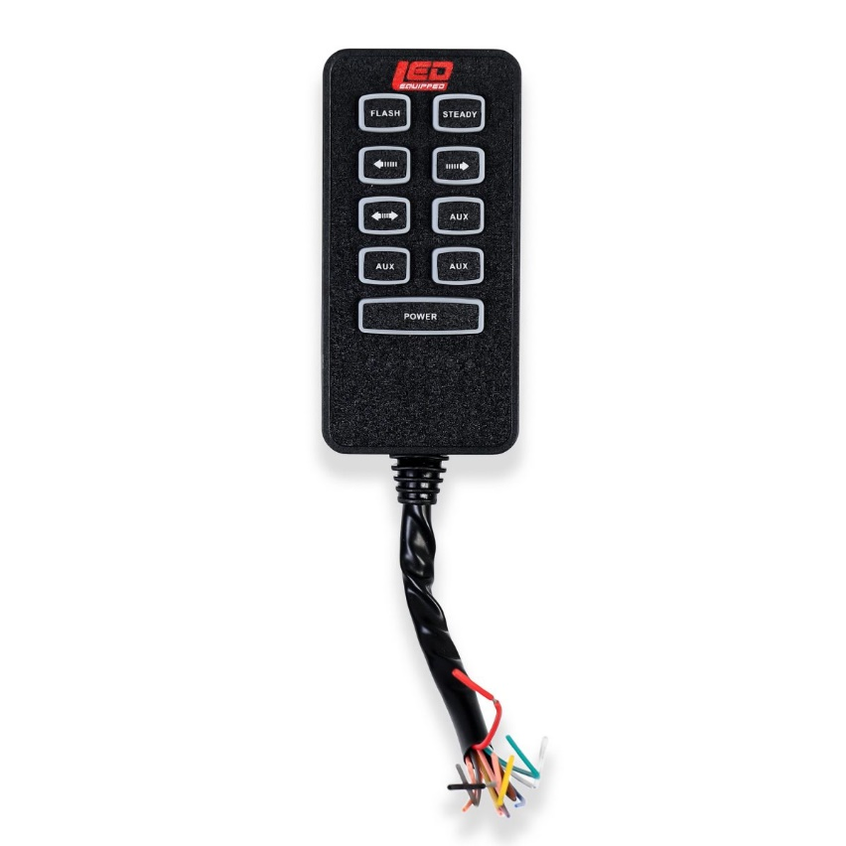
Handheld Controller

Handheld Controller Mounting Hardware

Instructions for Wiring and Operation

Installation and Wiring
To ensure proper installation installers are required to have a good understanding of automotive electronic systems and procedures for proper installation.
When you are drilling into the vehicle's surfaces, ensure that the area is free of any electrical wires, vehicle upholstery, fuel lines, etc. that could be damaged. All wiring passing through drilled holes should use grommets and silicone sealant to prevent wire or moisture damage when passing through compartment walls.
WARNING! Larger wires and secure or tight connections will ensure longer service life for your product. It is highly recommended that soldered connections have heat shrink used to protect the connection. Special attention should be given to the location and method of splicing wires to make electrical connections to protect these splices from lost power or connection and corrosion.
Insulation displacement connectors are not to be used. To reduce voltage drop, minimize the number of splices in the wires. The current carrying capacity of wires and fuses will be significantly reduced under high ambient temperature (e.g. under the hood).
All wires should be in accordance with the minimum wire size and other recommendations made by the manufacturer and be protected from hot surfaces and moving parts. Grommets, cable ties, looms, and other installation hardware should be used to anchor and protect all wiring. Fuses should be properly sized and located as close to the power take off points as possible to protect the wiring and device. To protect against short circuits, a fuse is included by LED Equipped for all products. Do NOT use a fuse with a higher amp rating than the initial fuse included.
After removing your product from the packaging, ensure that you conduct a full bench test of your product prior to installation on your vehicle. To do this, connect your product 12v + (positive) and 12v – (negative) to an appropriate 12v + (positive) power source and 12v- (negative ground). Installers will typically want to use the 12v – (negative) battery terminal over a frame-ground installation for proper operation. Many LED Equipped vehicle light bars come preinstalled with a 12v auxiliary power connector (cigarette plug) for ease of installation and to allow for simplicity of bench testing of your product. Once connected to an appropriate 12v power source (and GND), test each functional element of your product to ensure proper operation. If it is identified that any function is not working properly as a result of your bench test, please contact LED Equipped for further diagnosis and resolution. DO NOT in any circumstance attempt to open the product light housing to investigate and resolve the issue on your own. Doing so will result in voiding of the factory warranty. Once a successful bench test has been completed, and you have ensured the proper operation of your product, please follow the instructions below to install your product in your vehicle.

Installing the Handheld Controller

The Handheld Controller is the perfect solution for installers who want an advanced emergency warning light system that can be easily controlled from one single source. The Handheld Controller has been designed with nine (9) lighted soft-touch buttons with three (3) customizable buttons (AUX) that can be assigned to control each of your installed emergency warning lights and accessories. The Handheld Controller has been engineered with a five (5) amp capacity per switch, and will allow you to easily control your full installation of grille lights, work lights, LED light bars, traffic advisory light bars, and/or strobe lights.

The Handheld Controller’s compact design and high build quality and durability make it the ideal addition to your unique installation. The Handheld Controller includes embedded LED back lighting to allow you to quickly and easily see the functions that you need to execute your job in any operating environment. The Handheld Controller facilitates the ease of accessibility that you need to control each of your emergency vehicle warning accessories into one compact, easy to use, accessory and lighting control solution.

Wiring the Handheld Controller

The Handheld Controller provides an easy to configure solution for hard wiring your emergency vehicle warning lights and accessories. Your Handheld Controller comes preconfigured so that installation is as simple as wiring your warning lights and accessories to the controller.

Wiring the Handheld Controller is easily connected to each of your 12v warning lights and accessories to the desired Handheld Controller 12v + (positive) output, using the wiring specifications included in Figure 1 below. Please note that the 12v + (Positive/Red Wires) and 12v – (Negative/Black Wires) wiring connections must be made to an appropriate 12v power source and ground in order for your Handheld Controller to function properly.

All wiring connections should be secured using appropriate automotive connectors or through the use of soldered connections and all wiring utilized should be appropriately sized for the application. All connections should be protected by using heat shrink wire wrap in order to protect the connection. Special attention should be given to the location and method of splicing wires to make electrical connections to protect these splices from lost power or connection and corrosion.

Figure 1

Handheld Controller Wiring Specification
Wire Color | Button Function | Wire Color | Button Function
Black | Ground  12v - (Negative) | Red | Power On/Off  12v + (Positive)
Yellow | Flash | Green | Steady
Orange | Right to Left Arrow | Purple | Left to Right Arrow
Grey | Center Out Arrow | Salmon | AUX 1
Salmon | AUX 2 | Salmon | AUX 3

Figure 2 below provides a similar pictorial representation of the button layout of your Handheld Controller as well as the wiring pin assignment for ease of installation.

Figure 2

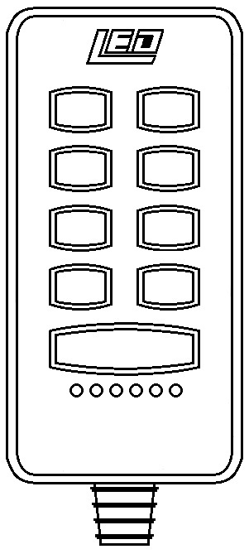
POWER
FLASH
STEADY
AUX
AUX
AUX

Handheld Controller Pin Wiring Assignment
Controller Button | Function | Controller Button | Function
FLASH | Momentary Button  Flash Pattern Selection | STEADY | Cruise Mode (Steady)
 | Right to Left Arrow |  | Right to Left Arrow
 | Center Out Arrow | AUX | Accessory Light Control 1
AUX | Accessory Light Control 2 | AUX | Accessory Light Control 3
POWER |  | Power Handheld Controller On/Off

Mounting the Handheld Controller

Included with the Handheld Controller are two screws and a mounting bracket that attaches directly to the back of the Handheld Controller for quickly and easily mounting your controller in your desired location on your vehicle. Using the two included mounting screws, secure the mounting bracket to your vehicle and simply slide the Handheld Controller into the mounting bracket for a secure fit for your Handheld Controller.

Operating the Handheld Controller

Once wired, operating the Handheld Controller, is as simple as depressing the desired controller button once to activate the selected emergency vehicle warning lights or accessories that you have installed, and their associated functions. When depressing the desired controller button, the backlight of the activated button will illuminate blue to indicate that the button is active. Depressing the desired controller button a second time will turn off the selected emergency vehicle warning lights or accessories.

In addition, below the ‘Power’ button on your Handheld Controller are six (6) LED indicators that will flash in accordance with the selected flash patterns of your emergency vehicle warning lights, so that you can quickly and easily identify which functions of your light bar are active.

At LEDEQUIPPED, we know that you need affordable lighting for your police, EMS, fire, construction, or towing vehicles and that safety and reliability are important to you. That is why all of our LED products feature powerful, up to date Generation LED lighting, perfect for your police, fire, construction, or EMS vehicle. LED Equipped focuses on a mission to carry out business ethically and with integrity, provide powerful products of the highest quality, maintain excellent and affordable prices, and to establish an unparalleled costumer service relationship beginning with establishing trust with our customers. As a provider of emergency vehicle lighting, we value the honesty, professionalism, and expertise present within our customer base.
For any questions regarding our products, contact us by calling us at +1 800-846-3940 or email us at sales@ledequipped.com.

